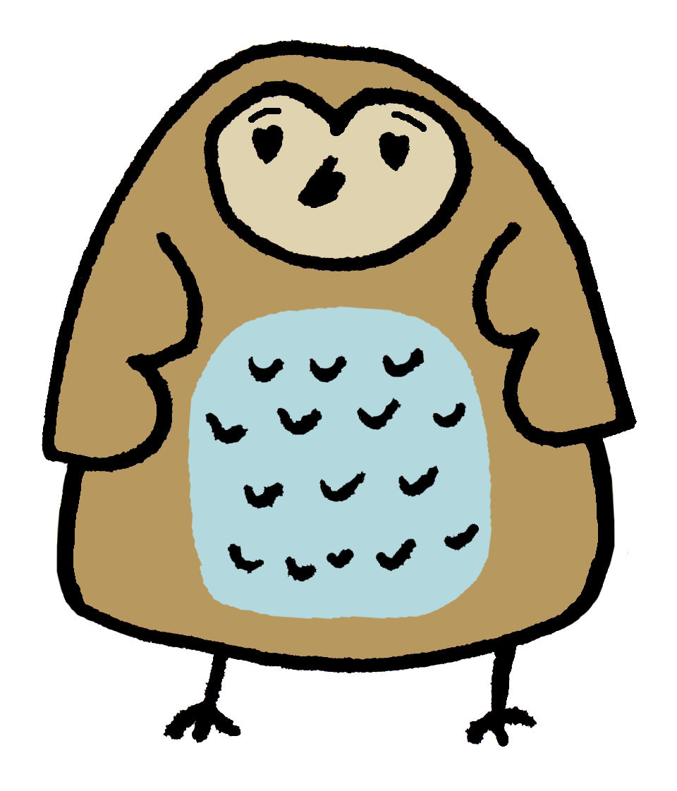

Townsend Barn Nursery
Registration Form

Townsend Barn Nursery referred to below as TBN
Basic
Name of child: |  |  | Date of birth:
Gender:  Known as: |  |  | Address:  Postcode:
Siblings name & age:
Mother:  Home tel.no:  Mobile:  Work place & Tel no:  Email: |  |  | Father:  Home tel.no:  Mobile:  Work place & Tel no:  Email:
Who has legal parental responsibility for your child?
Mother☐Father☐Both☐Other☐ Password……………………………………….……..
Who has permission to collect your child?

Please give details of any other who have legal responsibility:

Relationship to child: |  | Address: |  |  | Phone Number:
Emergency Contact – other than parent/carer:
Name: | Relationship to child: |  |  | Telephone:
Name: | Relationship to Child: |  |  | Telephone:

Personal Details
Special Dietary Needs diagnosed by a health professional: |  | Religion:
Any known allergies: |  | Religion:
Special occasions celebrated in your culture:

Language spoken at home:

If English is not spoken will this be your child’s first experience?
Yes☐No☐
Does your child have any special needs or disabilities?  Yes☐No☐  Details: | Any of these in place for your child:  Early years action plan☐  Early years action plan plus☐  Statement of special education☐  CAF☐
Do you have any concerns about your child’s hearing, speech or vision?

What special support will he/she require in the nursery?

Does your Child attend another Nursery / Childminder? Which?

Any other information?

Other Professionals involved with your child
Name:  Role:  Agency: |  | Name:  Role:  Agency: |  |  | Name:  Role:  Agency:
Do you have a health visitor? Yes☐No☐

Name: Telephone: Base:

Does your family have a social worker? Yes☐No☐
Name: Telephone: Base:
Do we have permission to share info with childrens centre? Yes☐No☐
What reason for involvement?

If your child has a child protection plan please make note here

Health details
Very occasionally a child may need urgent medical treatment. It is essential that we are able to contact you or your child’s doctor.
Doctors name:  Surgery address:  Telephone: |  |  |  | Vaccinations received:  HIB☐Diphtheria☐Polio☐  MMR☐Tetanus☐  Whooping cough☐  Meningitis C☐  Other:
Any medical conditions we should be aware of?

I give permission for TBN to give emergency first aid treatment and to seek emergency treatment and/or medication (GP or Emergency treatment) in absence of parent.

Sign: Date:
Attendance
 | Monday |  | Tuesday | Wednesday |  | Thursday | Friday
TIMES:

(Minimum 14 hours per week, minimum session time is 5 hours)

Full time or Term Time?.......................................................
Start date: …………………………………………………………………………

Settling in Date: ………………………………………………………………..

Parent Signature: | Print: | Date:

Registration fee of £100 to be paid at the time of registering. [See the separate TBN prospectus for explanation of what this includes]  One month’s TERM TIME notice is required if you reduce hours or wish to leave TBN.  One month’s notice is to be given for any holiday you wish to take.  I agree/confirm with the above and TBN’s fees/sessions as detailed in the TBN prospectus’s [separate document] ‘Fees and Sessions’ section given to me when enrolling at TBN.  Parent Signature  …………………………………………………………………  Date | Office use:  Registration fee paid:  Yes☐No☐  Birth Certificate:  Yes☐No☐  Red Book: Yes☐No☐  Manager’s signature:  Date:

- This Registration Form complies to our General Data Protection regulation (GDPR) and Privacy Policy 2018
- Further information can be requested from the Manager at TBN

Photography within the Nursery
As part of the Early Years Foundation Stage, TBN is required to take photographs. These images are used for display purposes and the child’s individual Learning journeys. They will be printed only in the nursery and not taken out of the nursery premises. At the end of each term the photos will be stored on a secure drive or deleted.
Please sign below to give TBN permission to take photographs of your child to be used within the key worker files and display boards. Please be aware that during nursery events and gatherings other parents and their families may be using recording devices and it is possible that your child may feature in some of their images.

SIGNED ………………………………………………………………….….. DATE…………………………………………………………

Photography for the Website, Newsletter & Social Media Sites
With your permission, TBN might like to use images of your child/children participating in various activities. We may wish to publish them on our website or in the quarterly Newsletter. We will not name any children.
Please sign below if you are happy to give permission for us to use images of your child/children.

SIGNED …………………………………………………………………….. DATE…………………………………………………………

Electronic Learning Journals.
I give permission for my child/children’s photograph[s] to be used in their online learning journal to monitor their learning and development. I understand these photographs may be included in another child’s observation and vice versa.

SIGNED ……………………………………………………………..… DATE…………………………………………………………

Sun Cream Consent

Name of Child................................................................
I give permission for a staff member to apply sun screen when my child needs it: - YES / NO?
I understand that I will supply and clearly label my child's sun cream.

If I forget to bring this in, runs out or is misplaced, do you give permission for us to use any spare lotion the school may have? YES / NO?

Does your child have any known allergies in association with sun creams? YES / NO?

(i.e. a particular make of sun cream) If yes, please give details..........................................................

SIGNED …………………………………………………………….…..….. DATE…………………………………………………………

Administering Medication & Calpol
Non Prescription medication e.g., pain and fever relief or teething gel may be administered but only with prior written consent with the parent and only when there is a health reason to do so.
A child under 16 should never be given aspirin unless prescribed by a doctor.
Only Staff at Townsend Barn Nursery who are First Aid Trained will administer medication.
A child is considered to have a fever if an oral temperature is taken that reads above 37.8°C

Please sign below if you give us permission to administer non-prescription medication, such as Calpol or teething gel to your child if they require it. TBN staff will always telephone the named parent/guardian for additional permission to administer Calpol. If a child has a temperature and parents cannot be contacted during a time period of 30 minutes, Calpol will be administered without telephone permission.

SIGN………………………………………………………….. DATE………………………………………………………


Early Intervention Team
Wiltshire Council has a duty to protect personal information belonging to the public, which it serves. The council is fully notified under the Data Protection Act 1998 and is committed to its principles and best practice in information security BS7799.
Every child has the right to have their individual needs met

Child’s name ……………………………………. Date of Birth ……………………………………

Whilst your child is attending …TOWNSEND BARN NURSERY
the Early Years Inclusion Adviser (EYIA) will work with setting staff to provide advice and support to ensure that your child’s needs are met. In some cases it may be necessary for the EYIA to talk to and share information with outside agencies. Wherever possible, this will always be discussed with you first. In order to keep you informed, it would be helpful to be able to contact you directly by telephone. To do this we would request that you add a contact number below.

Consent for Early Years Inclusion Adviser to observe your child and/or liaise with partner agencies

Parental/Guardian Agreement:
- I give my permission for (name of EYIA) …..
to observe my child whilst in attendance at (setting name)
TOWNSEND BARN NURSERY

- I give my permission for (name of EYIA) …
to liaise with our partner agencies including the local children’s centre.

- I understand that by contacting other agencies (name of EYIA)
will be working in partnership with me as parent/guardian to help meet my child’s needs.

- I do not wish my child to be discussed with (give details)
………………………………………………………………………………………………

- I understand that the information given above will be recorded and held on file as a paper and/or electronic copy

I agree to the information being recorded in this way and shared with relevant professionals, where appropriate. I understand that this information will only be used for the purposes of information sharing as set out in the Fair Process Notice and my consent is conditional upon this being complied with the duties and obligations under the Data Protection Act.
Parent/guardian with parental responsibility please sign below:
Signature:

Address:

Postcode:

Phone number:
Date:

Wiltshire Local Safeguarding Children Procedure
As a provider involved in the care of your child, we will try at all times to share any concerns we may have. However, in the event that we feel a child has been harmed or is at risk of significant harm, then we have a duty to follow the Wiltshire Safeguarding Children Board procedures as set out in the booklet ‘What to do if you are worried a child is being abused’ (DoH 2003). Our first concern will always be the welfare of your child.

Early Intervention Team Privacy Notice

The Data Protection Act 1998 gives individuals the right to know what information is held about them and requires organisations to adhere to the eight principles of data protection.

The information commissioners recommended in 2009 that the term ‘Fair processing notice be replaced by ‘Privacy Notice’ therefore we have amended this document accordingly.

Wiltshire Council’s early intervention team is committed to complying with the legislation by applying the principles of good information handling across its service. This leaflet sets out the basics of why we collect your information and how you can ask to see it.

As a team that is part of the local authority, we need to collect, process and keep data in relation to our statutory duties in the provision of education for children with difficulties and disabilities. We use the information to derive statistics to inform various decisions. The data is used in such a way that individual children cannot be identified. Information is also used to help plan our present and future service.

We keep information about your child so that we can provide the services that you need and for us to maintain a record of those services. This may include information that supports your child’s development, to monitor progress and to assess how well the early years setting is doing in terms of its special educational needs provision. This information may also include contact details, attendance information, characteristics such as ethnicity, special educational needs and any relevant medical information.

From time to time, we may be required to pass on some of this information to relevant and appropriate agencies or services from health, education and/or social care.

We are committed to maintaining the highest standard of security to protect your information. The early intervention team stores individual child information both as paper files and computer records.

Completed Common Assessment Framework (CAF) documents are also stored securely by other partner agencies in line with their own policies and procedures.

If you wish to access the personal data held about your child, please contact a member of the early intervention team or a member of the data protection team.

Please be aware, in order to fulfill our responsibilities under the Act, we may seek proof of the requestor’s identity and additional details to help us locate the information requested, before responding to the enquiry.

Townsend Barn Nursery Child Protection Responsibility Statement

Dear Parent/Carer,
As a provider of early years childcare and education that is registered with Ofsted, I am required to follow the Child Protection Procedures agreed with the Local Safeguarding Children Board and Ofsted within my responsibility to safeguard children.
As a provider of early years childcare and education involved in the care and education of your child, I will endeavor to share with you concerns I may have regarding injury or specific issues of concern at all times. A confidential record of such incidents will be kept and shared with you.
I do have a duty to refer to Social Services if I suspect your child is at risk of child abuse. I will inform you if I make a referral to Social Services, unless this would place your child at increased risk of significant harm. My first concern will always be the welfare of your child.
I have a copy of the Wiltshire Child Protection Procedures and guidance for you to see if you so wish.

Yours faithfully

Sarah Wheeler EYP
Manager of Townsend Barn Nursery

…………………………………………………………………………………………………

I -------------------------------------------------- (name of person with parental responsibility) have read and understood the above statement and agree with the procedures outlined to ‘Safeguard ‘my child.

Signature of person with parental responsibility…………………………………Date……………………………………

Equalities monitoring form
(As requested by Government)

White – British
- White
- Irish
- Traveller
- Any other white background

Mixed – White and Black Caribbean
- White and Black African
- White and Asian
- Any other mixed background

Asian or Asian British
- Indian
- Pakistani
- Bangladeshi
- Any other Asian background

Black or Black British
- Caribbean
- African
- Any other Black background

Chinese or other Ethnic Group
- Chinese

Any other ethnic background
- Please state

TOWNSEND BARN NURSERY
INFORMATION SHEET FOR
April 2025-March 2026

Name of Child / Children
DOB
Name of Parents
Address
 | MOTHER | FATHER | OTHER CONTACT
Email address
Mobile Number
Home Number
Work Number

Any other important information that we should know?

Full Time or Term Time | Session Times
 | MONDAY | TUESDAY | WEDNESDAY | THURSDAY | FRIDAY
DAYS PLEASE ✓
TIMES

Cooked Lunch, pudding (inc. Snacks, breakfast and light supper) - £6.95 per day | Cooked Lunch, pudding (including Snacks, breakfast ) - £5.00 per day
Yes / No | Yes / No

I AM HAPPY FOR MY CHILD / CHILDREN TO BE FEATURED ON SOCIAL MEDIA

Social Media
Yes / No

SIGN AND PRINT NAME………………………………………………………………………

DATE…………………………………………………………

